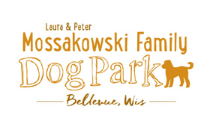

Dog Park Board of Directors Annual Meeting
January 15, 2016
2:00pm – 2:30pm
3100 Eaton Rd.

Meeting began: 2:10pm

Annual Board of Directors Meeting Attendance: Laura Mossakowski, Sandy Kemper, Paul Theys, Jennie Wertel

Officially Appoint Jennie Wertel to Secretary Role (Approved by Board)

Goals for 2016:
Phase I of Dog Park and complete fundraising for Phase I
Continue Fundraising efforts to reach $100,000 for completion of Phase I
Plan Grand Opening event once date known for opening
100 Women Who Care – drawing in February, winners chosen once per year
Continue to commit to monthly meetings for board members and committee

Motion to approve continuing roles of current board members (Laura, Paul)
Laura Mossakowski – President
Sandy Kemper – Vice President
Paul Theys – Treasurer
Jennie Wertel – Secretary

Meeting Adjourned: 2:35pm

Respectfully Submitted,
Jennie Wertel
Secretary

